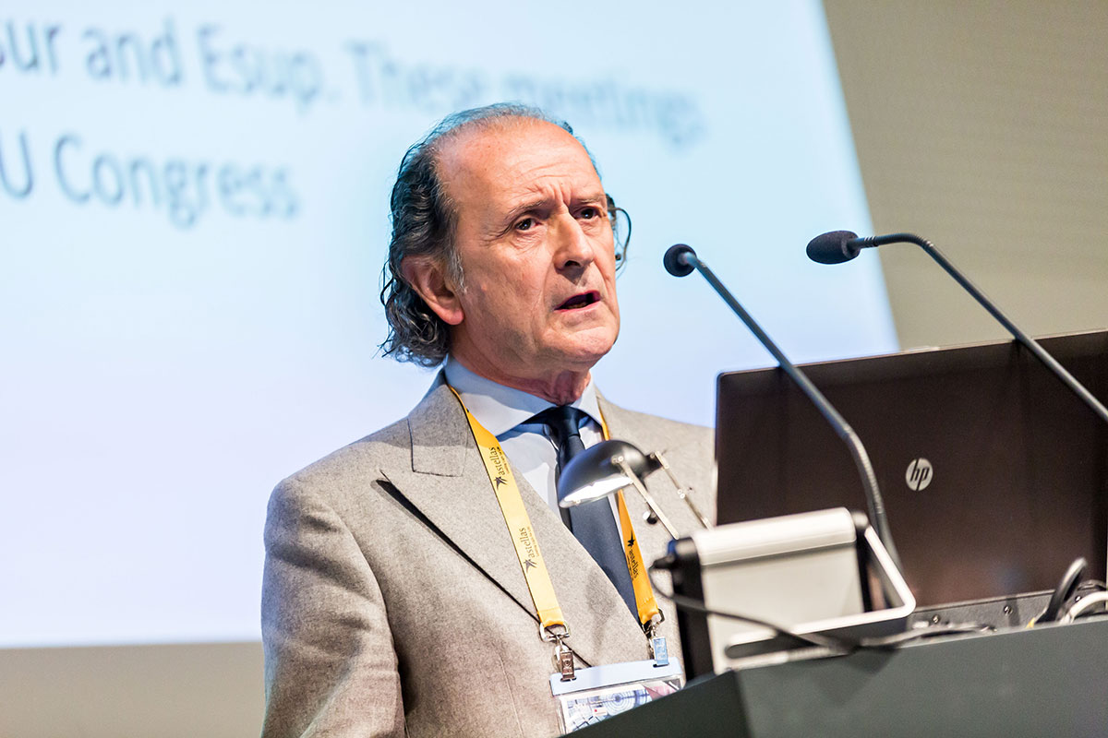

CURRICULUM VITAE PROF. MAURIZIO A. BRAUSI

Date and place of birth: Carpi (Modena) Italy 29/4/1951

23/7/76: Graduated in Medicine and Surgery

9/76 – 3/78: Assistant urologist AUSL Modena

1/3/78- 30.4.79: Assistant urologist at S. Maria Nuova Hospital (Reggio Emilia)

1978: Visiting dept. of urology Salpetriere University, Paris (1 Month)

30/4/79: Assistant urologist at Ramazzini Hospital USL of Modena

30/6/80: Speciality in Urology

1980: Researcher at the Columbia University Medical Center New York (USA)

1981: Researcher at the University of Florida (Jackson Memorial Hospital of Miami Prof. Politano)

1982: Researcher at the University of San Diego (Prof. Smidt)

1983: Speciality in Oncology at Modena University

1984: Fellow in Oncology at the University of Memphis (Prof. Mark Soloway)

10/85: Board in Urology and Pediatric Urology

86/89: Fellow in Oncology and research at the University of Memphis (basic and clinical research)

10/88: Speciality in General Surgery and position of Attending Urologist at USL of Modena

10/97: Teaching Professor of Urology at the University of Sassari

16/11/98 to march 2000: Position in Urology at HS Raffaele Institute Milan

81/ Present: Member of the EORTC (European Organization for Research and Treatment of Cancer). He was EORTC National Coordinator for Italy (10 years), Chairman Quality control (4 years), Chairman of the “Superficial Bladder Cancer Sub-committee” (5 years)

March 2000 - 2005: Chairman Dept. Of Urology Estense S. Agostino Hospitl Modena
From june 2000 to 2005 Chairman also dept of Urology B-Ramazzini Hospital Carpi.
In the same period he coordinated urology in the hospitals of Modena, Carpi, Finale E., Castelfranco Emilia, Vignola and Pavullo.

2005- present Chairman Urology Ausl Modena in B Ramazzini Hospital Carpi- Modena

June 2000-2011: Teaching Professor of Urology for Geriatrics at the University of Modena

October 2001/2003: Member bladder cancer committee-Seug

December 2001 - 2010: Member European Society of Uro-oncology (ESOU) board

March 2004 - 2010: Teaching Professor of uro-oncology at the university of Torino and Piemonte Orientale (Novara)

From 2001/2003: Coordinator and teacher of 3 courses of urology at the Columbia University (New York)

January 2005: Organizer II meeting of ESOU (European Society of Oncological – urology) in Bologna

December 2005/2013 Executive Member of SPO (Strategy Planning Office) EAU

September 2010/ Present: Chairman Elected European Society of Urological-Oncology (ESOU)

January 2010 /2013: Chairman Bladder Cancer Group of Italian Society of Urology (SIU)

Prof. Brausi published more than 300 articles in peer journals and cooperate in writing 7 books on oncology-urology (5 on bladder cancer and 2 in prostate cancer).
He is the author of 7 videos on “New technologies and development in surgical approaches” presented at the EAU 2001 (partial nephrectomy in giant angiomyolipoma),at the European Society of Oncologic-Urology (ESOU 2006) : Radiofrequency ablation (RITA) of small renal tumors, at ESOU 2005 (Prostate sparing Radical Cystectomy), at ESOU 2007: Extended lymphadenectomy for muscle invasive TCC of upper urinary tract, at ESOU 2008: Anatomical, mininvasive Radical Cystectomy: The Modena Technique, AT The International meeting on focal therapy 2009 :Electroporation: a novel technique for the focal treatment of localised prostate Cancer (EAU 2011) and Cellvitio for the Diagnosis of Bladder Cancer EAU (2013).

He was visiting Professor at the University of Aachen (1989), Vienna (1998), Milan (2000).
He is member of the AUA, EAU, ESOU, SIU (International Society of Urology), SIU (Italian Society of Urology) SUNI and CLURON, SPO. He won 7 awards for best poster presentation at the EAU Congresses (Birmingham, Vienna, Milan, Paris).

EAU 2012 (Paris) he won the Third prize for the Best abstract in Oncology : “BCG one third dose vs full dose one year vs three years of maintenance. Final results of an EORTC GU Group randomized trial in NMIBC”
He was invited as visiting Professor performing live surgery at the dept. of urology in Bolzano, at the University of Athens, University of Bruxelles, University of Milan.

April 2008/ 2012: Regional Coordinator of SIURO (Italian Society of Uro-Oncology)

September 2009/ Present : faculty member of the European School of Urology (ESU). Professor Brausi held courses in Romania (Bucarest), Russia (Novodgorov), Uzbekistan (Tashkent).

In January 2011 he was Chairman of the ESOU meeting in London

In June 2011 chaired a Course for European School of Urology (ESU) as Chairman in Slovenia.

In February 2012 he was visiting professor at the dept. of urology of Fundation Puigvert of Barcelona (prof J Palou) doing live surgery: Minivasive Radical Cystectomy and giving lectures on Non Muscle Invasive Bladder Cancer.

February 2012 he was visiting professor at the University of Prague (Prof. M Babjuk): he gave a lecture on radical cystectomy in elderly patients.

May 9.2012: visiting professor at the University of Aachen (Germany) performing live surgery : Extended pelvic lymphadenectomy in recurrent adenocarcinoma of the prostate after radical prostatectomy. In this occasion he gave a lecture on “ The actual treatment of NMIBC”.

May 2012: Board member of Wuof (World Uro-Oncology Federation )

January 2013 Organizer and Chairman of the 10th ESOU meeting in Rome
SIU-WUOF 2013(Vancouver): PI of “International Bladder Cancer Prevention Program”

July-August 2013 : visiting professor at the University of Melbourne, Australia and participated as speaker in the International Meeting on Prostate Cancer (The Role of Focal therapy: the European Perspectives)

September 2013 /present: Director Prostate Cancer Unit Ausl Modena (Carpi-Modena)

February 2014 visiting professor at the University of Salzburg (Austria) and gave a lecture on “New trends in the treatment of NMIBC”

29 September 2014: President of the Italian Society of Urology elected (Florence)

Ocober 12-15 .2014 he received the prize for the best poster of the Moderated poster Session 8 : Bladder Cancer: Invasive and Superficial Disease titled “ Optical Biopsy withConfocal Laser Endomicroscopy (CLE): A New Technology for Diagnosis of Bladder Cancer- Preliminary results of a Phase II Pilot Study” at the SIU Congress Glasgow

4-7 december 2014 he was elected as Member of the Association of Academic European Urologists (AAEU)

January 2015 Co-author (with Konety and Chang) of a book titled “ Management of Bladder Cancer” (Chapter 21)

17-20 January 2015 dr Brausi chaired the ESOU stand alone meeting held in Munich

21-22 february 2015 Invited lecturer by the Hungarian Society of Urology In Budapest

November 2015- Present Executive Board Member of the Italian College of Surgeons (CIC)
  - January 2016 :Chairman ESOU meeting Warsaw 20-22 January 2017: Chairman ESOU Meeting Barcelona
December 2017: Coordinator Bladder Cancer Group for SIU (Italian Society of Urology)

January 2016 - Present : Member Scientific Committee ESMO (European Society of Medical Oncology)

January 2016 -Present : Member Scientific Committee SIU (International Society of Urology)

2014- Present: Reviewer Journal of Urology

26-28 January 2018 : Chairman ESOU meeting Amnsterdam

I undersign, authorize the processing of my personal data hereby transmitted in compliance with italian act N 196 2003.

22.02.2018

Maurizio Brausi MD
Director of Urology Ausl Modena
Chairman Esou (European Section Oncology-Urology)
Director ProstateCancer Unit Ausl Modena
p.President Italian Society of Urology (SIU)
Executive member Italian College of Surgeons (CIC)

